Technical/Functional Requirements for an E-commerce

Website Security/SSL Certificate

Website Performance

Scale According to Your Needs

Think Mobile First

Cloud Hosting

Website Updates

Data Engineering

Third-Party Integrations

Hosting or plan upgrades

Site security

Site backups

Shipping software or Dropshipping software

payment gateway

----------------------------------------------------

**Third-Party Integrations**- This requirement concerns both systems streamlining business operations (like ERP, CRM, PIM) and flexible payment gateways for your customers. Specifying third-party integrations will make the architecture of the e-commerce business more structured and ready for future business scaling.

Examples: Shopify, Stripe, Paypal, AmazonPay

### User-Friendly/Mobile-Adaptability- The website should be specialized/adapted for the small screens on smartphones and tablets. Users should be able to scroll through without worrying about the images or the text of the website’s content not fitting into the screen, and therefore being cut off. For example; The photos and all of the content should be able to adapt seamlessly every time the user rotates their mobile device.

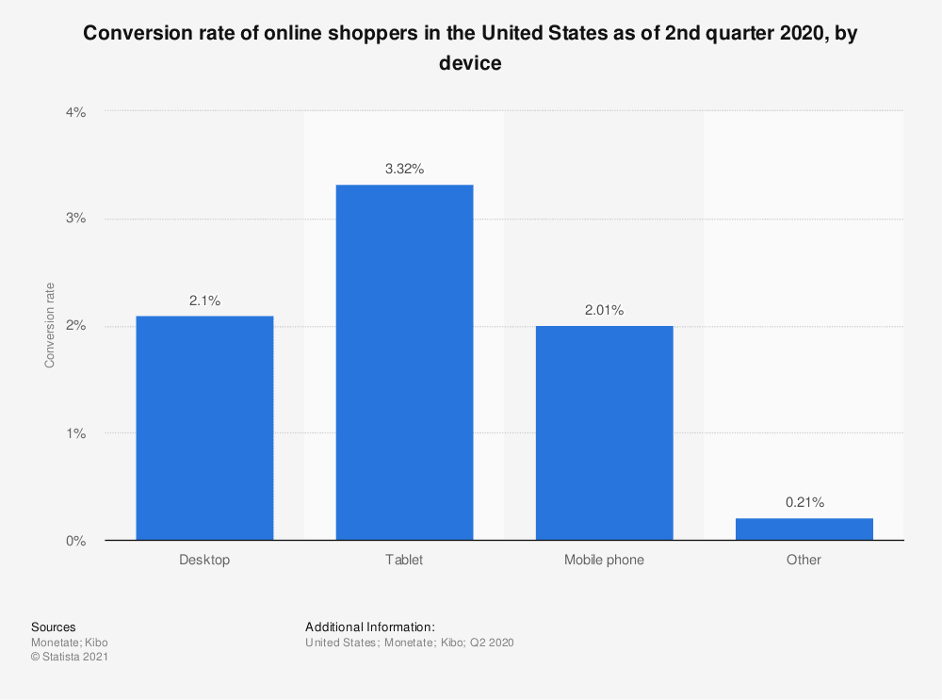

It is essential to conduct market research to understand n which devices the target audience is most likely to carry out their shopping. It is important to know where should necessary buttons be placed on the website and the mobile version of the website. It is beneficial for the check out button to reach the customer’s thumbs since most people prefer to hold and scroll mobile devices with only one hand.

### Product Attributes- Features on the website or app, such as product size, colour, product categories, prices, add ons, should be listed and specified for the developers. Whether the product attributes will appear on a drop-down menu or just on the sidebar/top bar menu should also be determined.

It is essential to specify whether or not the images should have the option to zoom in and whether they will support only single product orders or bundles.

### **Order & Checkout Flow**- Functional requirements should specify how the orders are to be processed in particular, indicate whether the customer needs to register to make a purchase or if a guest checkout will be enabled, and if guests or members will be able to see order status, as well as if they will be able to track their orders live. (See the exact location of a package). In conclusion, it is crucial to be as detailed about the orders and check out flow functionalities as possible. It is also essential to determine where in the checkout process will the discount policy be mentioned and how will the customer input any promo codes available. Order statuses would be the following: confirmed, processing, shipped, returned.

### **Social Sharing-**Online presence goes alongside social media presence in e-commerce. Allowing customers to share the storefront content on social media leads to higher brand awareness. Identifying the target audience’s favourite social media networks is crucial. Also, letting consumers share products, blog posts, and photos of the products drives traffic from their networks. Thus, adding a corresponding button to photos, such as a ‘buy’ button, has a higher chance of converting traffic.